Business Insights Report on Marketing Campaign
Exploratory Data Analyst(EDA)
Objective : The objective of this project was to perform Exploratory Data Analysis (EDA) on a marketing campaign dataset to identify customer purchasing behavior, evaluate campaign effectiveness, analyse sales channels, and provide recommendations for improving marketing return on investment (ROI).
Overview
- Dataset contains customer demographics, income, purchase behavior, product spending, and campaign responses.
- Records: 2,240 customers
- Missing values were identified and handled during data preprocessing.
- Date columns were standardized, and a Total Spending feature was created for analysis.
Key Findings
- Wine Products generated the highest revenue, followed by Meat Products.
- Store Purchases were the most preferred purchase channel among customers.
- Customer income showed a positive relationship with overall spending.
- High-spending customers tended to purchase across multiple product categories.
- Website visits were relatively high, but web purchases indicate opportunities for improving conversion rates.
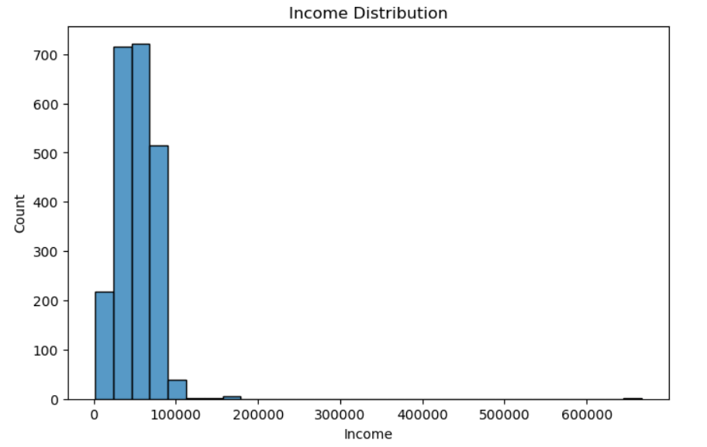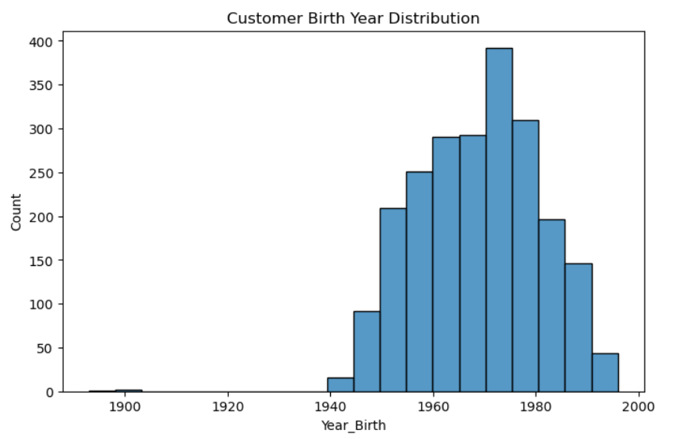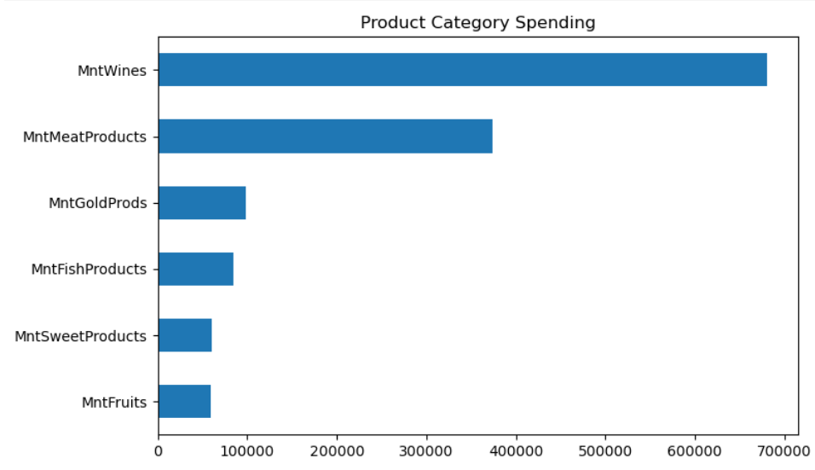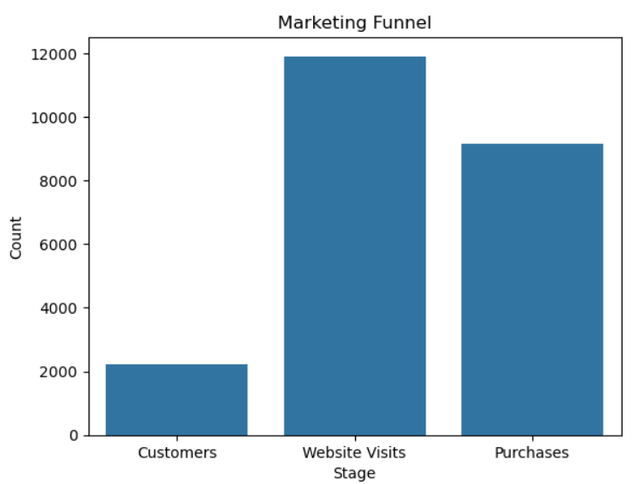
Business Recommendations
- Increase marketing efforts for Wine and Meat Products as they contribute the most revenue.
- Focus promotional campaigns on high-income customer segments to maximize sales.
- Strengthen in-store marketing strategies since store purchases dominate other channels.
- Improve website experience and online promotions to increase web purchase conversions.
- Implement customer loyalty programs to retain high-value customers and encourage repeat purchases.

Conclusion : The analysis revealed valuable insights into customer spending behavior and purchasing preferences. Wine and Meat Products emerged as the top-performing categories, while Store Purchases remained the leading sales channel. By focusing on high-value customers, optimizing product promotions, and improving digital engagement, the company can enhance marketing effectiveness and achieve better ROI.

